**Paper title (Arial, 11 pt, bold)**

**Author 1 (Name and Surname) (Arial, 10 pt, bold)**Name of Institution, Country (Arial, 10 pt)  
E-mail: (indicate author's e-mail address)  
ORCID: (reference is provided: https://orcid.org/****-****-****-****)

**Author 2 (Name and Surname)**Name of Institution, Country  
E-mail: (indicate author's e-mail address)  
ORCID: (reference is provided: https://orcid.org/****-****-****-****)

**Author 3 \*\*\***

**Abstract.** The abstract introduces the problem under study, its significance, the aim of the study, the methods, and the main results. The abstract should be between 1000-1500 characters in length and written in the language of the article. The abstract, key words and JEL codes are in Arial font, size 10 pt. In the footer at the bottom of the first page, include the names of all authors and the date of submission. The text in the footer should be in Arial font at 7 pt.

**Keywords:** 3-5 keywords, separated by commas.

**JEL Code:** JEL codes 1 to 3 should be assigned according to the entity descriptor of the economic classification) <https://www.aeaweb.org/econlit/jelCodes.php?view=jel>. Codes separated by commas.

## Introduction **(Arial, 10 pt., bold)**

This template provides information for authors on the formatting requirements and specifications for the article they are preparing. The recommended length of the article is approximately 3000-8000 words. The font used throughout the article should be Arial, size 10, line spacing 1.15, paragraph spacing 6 pt. Text should be justified on both edges, with indentation of the first line set to 0 cm.

This template is designed to fit A4 paper size (21 cm x 29.7 cm) in MS Word format. Examples of the font style are given throughout the template, with details in brackets.

The introduction of the article should reveal the relevance and novelty of the topic, formulate the aim of the research, define the object of the research, describe the methods of the research, and indicate the extent of research on the topic. The introduction may also present the scientific problem to be solved, the possible solutions, and the limitations of the research. In addition to the aim of the study, the article may include research objectives.

## **1. Article structure (Arial, 10 pt., bold)**

The required basic elements of a paper are: an abstract, keywords, introduction, body of the paper, and conclusions, followed by a list of references. The structure of the article’s text depends on the author's chosen topic and is not restricted. The following classical structure is recommended, though not mandatory: 1) analysis of the literature on the topic; 2) study methodology; 3) analysis and evaluation of the study results. The subdivision of chapters and other technical formatting requirements are provided in Chapter 2.

## **2. Technical specifications of the article**

### **2.1 Sub-sections (Arial, 10 pt, bold)**

Where appropriate, sections of the article may be broken down into smaller structural parts such as sub-sections. However, it is not recommended to subdivide a subsection into even smaller parts. For emphasis or highlighting, certain areas can be highlighted in **Bold** or *Italic*.

Words, phrases, or various names that are frequently used may be abbreviated. Commonly understood abbreviations do not require further explanation (e.g., kW, Dr., Oct., etc.). Other abbreviations or acronyms, which are formed in various ways, should be explained in the text the first time they are used, or a list of them with explanations can be provided at the end of the article (e.g., chief executive officer (CEO)).

To avoid confusion of terminology, a term used in the text should be followed by the term in the original language in brackets, indicating the language, and the term should be written in *Italic* style (e.g., cosmetic balance sheet (German *bilanzkosmetik*), etc.

### **2.2 In-text citation**

In-text citation of sources should follow APA citation style (<https://apastyle.apa.org/style-grammar-guidelines/references/examples>). Some examples of citations are provided in Table 1.

Table 1. **Guidelines for citing sources**

| **Source** | **In the reference list** | **In-text** |
| --- | --- | --- |
| E-journal article (with DOI), one author | Dhillon, P. (2022). How to write a good scientific review article. *The FEBS Journal*, *289*(13), 3592–3602. <https://doi.org/10.1111/febs.16565> | Dhillon (2022)...  Or ...(Dhillon, 2022) |
| Article in a printed journal, two authors | Jusytė, J., & Kamarauskienė, I. (2014).Viešojo sektoriaus subjektų finansinių ataskaitų santykinė analizė: teoriniai ir praktiniai aspektai*. Buhalterinės apskaitos teorija ir praktika, 16*, 63–77. | Jusytė and Kamarauskienė (2014)...  Or ...(Jusytė & Kamarauskienė, 2014) |
| E-journal article (without DOI), two authors | Watts, R.L., & Zimmerman, J.L. (1990). Positive accounting theory: a ten year perspective. *Accounting Review*, *65*(1), 131–156. <https://www.jstor.org/stable/247880> | Watts and Zimmerman (1990)...  Or ...(Watts & Zimmerman, 1990) |
| Three or more authors | LaPlaca, P., Lindgreen, A., & Vanhamme, J. (2018). How to write really good articles for premier academic journals. *Industrial Marketing Management*, *68*, 202–209. https://doi.org/[10.1016/j.indmarman.2017.11.014](https://doi.org/10.1016/j.indmarman.2017.11.014) | LaPlaca et al (2018)…  Or …(LaPlaca et al. 2018) |
| Same author(s), same year | Tamulevičienė, D., & Mackevičius, J. (2019a). Išlaidų klasifikavimo informacijos naudojimas įvairiems įmonių veiklos tikslams = The usage of information on costs classification for various purposes of enterprises’ activities. *Informacijos mokslai*, 86, 157–173. <https://doi.org/10.15388/Im.2019.86.31>  Tamulevičienė, D., & Mackevičius, J. (2019). Methodology of complex analysis of tangible fixed assets. Entrepreneurship and Sustainability Issues, 7(2), 1341–1352. <https://doi.org/10.9770/jesi.2019.7.2(38)> | Tamulevičienė and Mackevičius (2019a) …  Or … (Tamulevičienė & Mackevičius, 2019a)  Tamulevičienė and Mackevičius (2019b) …  Or … (Tamulevičienė & Mackevičius, 2019b) |
| A book | Tracy, T.C. (2024). *How to Read a Financial Report: Wringing Vital Signs out of the Numbers*. John Wiley & Sons. | Tracy (2024)...  Or ...(Tracy, 2024) |
| A group or organisation | American Psychological Association. (2024). *Common Reference Examples Guide.* <https://apastyle.apa.org/instructional-aids/reference-examples.pdf> | American Psychological Association (2024)…  Or …(American Psychological Association, 2024) |
| Website | Simplified science publishing. (2024, September 3). Internet addiction. *How to Make good figures for scientific papers*. Retrieved from <https://www.simplifiedsciencepublishing.com/resources/how-to-make-good-figures-for-scientific-papers> | ...(Simplified science publishing, 2024) |

*Source:* compiled by authors based onMendeley (2024), American Psychological Association (2024)

When preparing your manuscript, pay attention to using quality sources. Choose high-level scholarly publications for citations and avoid inappropriate citations, unrelated references, or unreviewed online articles, etc.

### **2.3 Equations and statistical rules**

The formulas or models used to perform the calculations should be included in the description of the research strategy. Mathematical formulas or other mathematical expressions should be inserted in the text in a separate paragraph. Formulas should be written using the Microsoft Equation formula builder and numbered consecutively with Arabic numerals in brackets, aligned to the right margin:

$y=ax+b$; (1)

here:

y – is the first variable;

a – is the second variable;

x – is the third variable;

b – is the fourth variable.

The statistical methods and models used should be presented with their descriptions and full parameters.

### **2.4 Graphical material**

It is recommended to present the results of the study in figures or tables when systematizing, comparing, or summarizing the information or presenting the results. The figure number and title should be placed below the figure.

Figures should be clear and legible, in JPEG, TIFF, or PNG formats, and may be in black and white or color (see Figure 1).

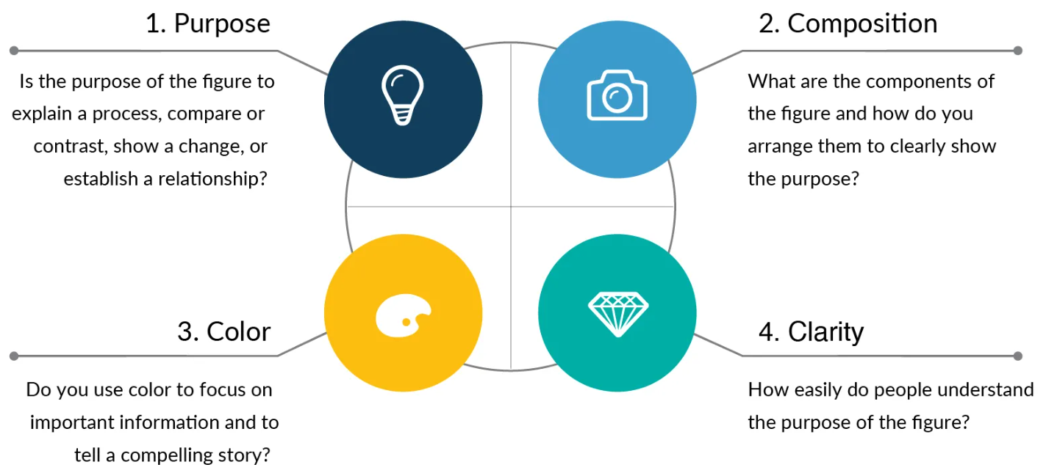

Fig. 1: **How to create a quality image**

*Source*: Simplified science publishing (2024)

Tables in the work shall be in Arial font, size 10 pt, single line spacing. Tables are presented as editable text and not as figures. The table number and title are written above the table (see Table 2).

Table 2. **Theses for the presentation of graphic material**

| **No.** | **Description of the thesis** |
| --- | --- |
| 1 | Tables and figures should be included in the text at the appropriate place in the article. |
| 2 | Figures and tables must be logically titled. |
| 3 | Each figure or table must be followed by a reference to the source(s) or an acknowledgment that the material has been compiled by the author(s). |
| 4 | Figures and tables should be numbered separately and consecutively using Arabic numerals. |
| 5 | Figures and tables should be aligned on the left-hand side of the page. |
| 6 | Leave one 10 pt blank line before and after the figure or table. |
| 7 | Graphic material should not be too crowded or too long. Symbols must be clear and easily distinguishable. |
| 8 | Graphical material should not duplicate textual information. |

*Source:* compiled by authors

Each figure or table should be followed by a description, an explanation, and the authors' main insights.

### **2.5 Discussion and limitations of the study**

After presenting the main results of the study, it is recommended to discuss the implications of the results. The discussion should not focus on restating the results, but on providing a critical assessment of them. The results can be compared with the work of other researchers. If the results of the study are contrary to the work of other researchers, this should also be reflected in the discussion, which should address why these results were obtained and the reasons behind them.

It is also useful to discuss the limitations of the study and assess what further research would be needed to answer the questions raised by the results or to further explore the research problem.

## **Conclusions (recommendations, discussion questions)**

1. This chapter presents the detailed conclusions of the study. If the paper includes objectives, it is advisable to relate the conclusions to the objectives.

2. The contribution of the research to the advancement of the field and its scientific novelty should be highlighted.

3. Avoid listing results or repeating statements from the discussion.

**Acknowledgement, explanation, additional information**

In this section, you can thank individuals who have contributed to the manuscript but are not co-authors of the work (such as providing technical assistance, help with writing, or proofreading). You can also acknowledge the institution that funded the research or provided a grant or scholarship.

Explanatory notes or additional information related to the preparation and publication of the paper can be provided. In the event of a conflict of interest, possible links or lack of links should be explained. Additionally, if artificial intelligence was used at any stage of the work, this must be disclosed in this section. It should specify which parts of the study, to what extent, and what kind of artificial intelligence was used.

### **References**

The text should cite all scientific publications on which your work is based. The alphabetical list of sources and references should follow the international APA referencing system (see Table 1). Sources by the same author should be listed chronologically by date of publication. Use Arial font, size 9 pt., line spacing 1.15, paragraph spacing 6 pt., with text aligned to the left margin and no indentation for the first line of a paragraph.

American Psychological Association (2024, September 4). *Reference guide for journal articles, books, and edited book chapters*. Retrieved from <https://apastyle.apa.org/style-grammar-guidelines>

Dergaa, I., Chamari, K., Zmijewski, P., & Saad, H.B. (2023). From human writing to artificial intelligence generated text: examining the prospects and potential threats of ChatGPT in academic writing. *Biology of Sport*, *40*(2), 615–622. <https://doi.org/10.5114/biolsport.2023.125623>

Dhillon, P. (2022). How to write a good scientific review article. *The FEBS Journal*, *289*(13), 3592–3602. <https://doi.org/10.1111/febs.16565>

LaPlaca, P., Lindgreen, A., & Vanhamme, J. (2018). How to write really good articles for premier academic journals. *Industrial Marketing Management*, *68*, 202–209. https://doi.org/[10.1016/j.indmarman.2017.11.014](http://dx.doi.org/10.1016/j.indmarman.2017.11.014)

Mendeley (2024, September 4). *APA format citation guide.* Retrieved from <https://www.mendeley.com/guides/apa-citation-guide/#1_Ref_List>

Simplified science publishing (2024, September 04). *How to make good figures for scientific papers*. Retrieved from <https://www.simplifiedsciencepublishing.com/resources/how-to-make-good-figures-for-scientific-papers>

**Author 1 (Name and Surname):** information about the author: education, scientific and pedagogical title(s), fields of scientific interest, the name of the institution represented, the position held by the author, the address of the institution.

**Author 1 (Name and Surname):** information about the author: education, scientific and pedagogical title(s), fields of scientific interest, the name of the institution represented, the position held by the author, the address of the institution.

**Author 3 \*\*\***